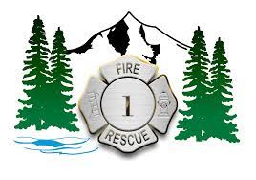
Apprentice Panel Interview Questions

- What two things are most important to you in a career and how do you see those things being supported as an Apprentice Firefighter with XXXX Fire?
- Can you tell us about a time in your life that you failed and what came of that failure?
- Who has been the biggest influence in your life and why?
- The fire service can be a stressful occupation, how do you deal with stress in your daily life?
- XXXX Fire received over 400 applications for the apprentice program. We now must narrow that number to 20 apprentices for the chief’s interview. Why should we choose you?
- This concludes the interview, is there anything you would like to add or go back and address from any of the previous questions?

